**SOFTWARE**

**REQUIREMENTS SPECIFICATION**

**For**

# Hotel Reservation System

**Prepared by:-**

Deepak Raja *.M*

*Sofiya Nivedhini .J*

*Ajith Das.S*

*Kaviya.A*

## Introduction

The Hotel Reservation System is a tool for booking the rooms of Hotel through online by the Customer. It provides the proper management tools and easy access to the customer information.

### Purpose

This Hotel Reservation System Software Requirement Specification (SRS) main objective is to provide a base for the foundation of the project. It gives a comprehensive view of how the system is supposed to work and what is to be expected by the end users. Client’s expectation and requirements are analyzed to produce specific unambiguous functional and non-functional requirements, so they can be used by development team with clear understanding to build a system as per end user needs.

This SRS for HMS can also be used for future as basis for detailed understanding on how project was started. It provides a blueprint to upcoming new developers and maintenance teams to assist in maintaining and modifying this project as per required changeability.

* Entire document should be justified.
* Convention for Main title

Font face: Times New Roman



Font style: Bold

Font Size: 14

* Convention for Sub title

Font face: Times New Roman



Font style: Bold

Font Size: 12

* Convention for body

Font face: Times New Roman



Font Size: 12

### Scope of Development Project

The HMS project is intended for the reservations for room that can be made through online. It will be able to automate the various operations of the Hotel. Our Hotel Reservation System will have three end users: Customer, Receptionist, and Hotel Manager. Hotel Reservation System will consists of Booking Management System, DBMS Server, and Report Generator. Customers will

be able to check for room’s availability, select the rooms, and pay for the room. Receptionist will have access to update or modify booking details. Manager will able to view the financial report and able to update room information such as cost and category.

The main goal of this introduced automated HMS software is to simplify every day process of hotel. Day to day Hotels are increasing and they need to automate to provide customer ease of access. It will be able to take care of services to customer in a quick manner. This automation will be able to replace the drawbacks of large customer information physical files which were difficult to handle. Secure Transaction, quick retrieval of information, ease of use, quick recovery of errors, fault tolerance are some of the benefits that development team will be working on to achieve end user satisfaction.

### 1.4 Definitions, Acronyms and Abbreviations

JAVA -> platform independence

SQL-> Structured query Language

ER-> Entity Relationship

SRS-> Software Requirement Specification

HMS->Hotel Reservation System

DBMS->Database Management System

### 1.5 References

* Hotel Reservation System: https://www.scribd.com/doc/63824633/Hotel-Management System
* Case Study: <https://www.scribd.com/doc/27927992/Hotel-Management-Case-Study>
* Requirement Engineering: http://morse.inf.unideb.hu/valseg/gybitt/07/ch02.html

## 2. Overall Descriptions

### 2.1 Product Perspective

**BROWSER**

**| HTTPS (Application Server) JDBC Database**

**| -------🡪 --🡪**

**|**

**(SERVER)**

**2.2 Product Function**

Our Product General functions are:

• Customer Registration

• Check for Availability Of Rooms

• Display the Rate

• Confirmation Of Booking

• Email Notification

• Payment

• Set Room Details

• Manage Booking Details

• Generate Report

• Customer Service

### 2.3 User Classes and Characteristics

There are 3 user Levels in our Hotel Reservation System:

A. Hotel Manager

B. Receptionist

C. Customers

**Hotel Manager**

The hotel system is completely accessible to the manager. The manager is the only one in charge of overseeing the workforce and hotel resources. The manager has access to all reports, including those on finances, customers, bookings, and rooms, and may review, evaluate, and make decisions based on them.

A manager must have prior hotel management expertise in addition to a foundational understanding of databases and application servers.

**Receptionist**

The primary goal of a hotel receptionist is to deliver excellent customer service. Compared to the manager, she has less access. The booking details are under her control. She has the power to check room availability, add customers, validate reservations, and amend booking information. A hotel manager would likely prefer a receptionist with strong communication abilities and fluency in the English language. She ought to know the basics of IT.

**Customer**

A key component of the system is the customer. Customers can examine the details and price range of the available rooms. They ought to be able to verify the reservation and, if needed, cancel it. Customers can forward their inquiries using the customer support desk portal. The web user interface should, at minimum, be usable by the customer.

* 1. **Constraints**
* Memory: System will have only 10GB space of data server
* Language Requirement: Software must be only in English.
* Budget Constraint: Due to limited budget, HMS is intended to very simple and just for basic functionalities. UI is going to be very simple.
* Implementation Constraint: Application should be based on Java only.
* Reliability Requirements: System should sync frequently to backup server in order to avoid the data loss during failure, so it can be recovered.

**2.5 Assumption and Dependencies**

It is assumed that system developed will work perfectly that’s going to be developed under the Windows OS, and Apache Server with Mongo DB database. If in case of any difficulties, SRS should be flexible enough to change accordingly.

**3 SPECIFIC REQUIREMENTS**

**3.1 External Interface Requirements**

**User Interfaces**

The user interface for system shall be compatible to any type of web browser such as Mozilla Firefox, Google Chrome, and Internet Explorer.

**Software Interfaces**

**Web Server**

• Apache Tomcat Server , OS (Windows)

**Database Server**

• Mongo DB, OS (Windows)

**Development End**

• J2EE,Java,JSP,Servlet,HTML,XML,JavaScript, OS(Windows)

**Communication Interfaces**

The System shall be using HTTP/HTTPS for communication over Internet and for intranet communications, it shall use TCP/IP protocol.

**Hardware Interfaces**

**->Server Side**

**->Client Side**

**Server Side**

Monitor-Resolution: 1024x768

Processor-Intel or AMD 2GHZ

RAM-4GB

Disk Space-10GB

**Client Side**

Monitor-Resolution: 1024x768

Processor-Intel or AMD 1GHZ

RAM- 512MB

Disk Space- 2GB

**3.2 Functional Requirements**

**Registration**

FR1.

The Customer should be able to register with their details

FR2.

The system should record following customer details into member database.

* Name
* Email
* Password
* Address
* DOB

FR3.

The system shall send verification message to email

**Logging In**

FR4.

The system should verify the customer email & password against the member database when logging in

FR5.

After login, member should be directed to Home screen

**Reservation**

FR6.

The system should enable customer to check for availability of rooms

FR7.

The system should display rate for all rooms

FR8.

The system should allow customer to confirm or cancel the booking

FR9.

The system should record booking details into database

**Receptionist Access**

FR10.

The system should allow Receptionist to update, add or delete booking information

FR11.

The system should provide customer desk portal access to receptionist for providing response to customer inquiry

**Manager Access**

FR12.

The system should generate financial and customer report for manager

FR13.

The system should enable manager full modification access to customer ,booking and room information

**Payment Management System**

FR14.

The system should allow customer to pay bill via online using credit or debit card

**3.3 Performance Requirements**

NF1.

Data in database should be updated within 2 seconds.

NF2.

Query results must return results within 5 seconds

NF3.

Load time of UI Should not take more than 2 seconds

NF4.

Login Validation should be done within 3 seconds

NF5. Response to customer inquiry must be done within 5 minutes.

**3.4 Security Requirements**

NF6.

All external communications between the data’s server and client must be encrypted

NF7.

All data must be stored, protected or protectively marked.

NF8.

Payment Process should use HTTP over Secure protocol to secure the payment transactions

**3.5 Safety Requirements**

NF9.

should be backed up every hour.

NF10.

Under failure, system should be able to come back at normal operation under an hour.

**3.6 Capacity Requirements**

NF11.

Not more than 10,000 members to be registered

NF12.

System need to handle at least 20 transactions during peak hours.

**3.7 Availability Requirements**

NF13.

Report should be generated automatically every day for manager and anytime upon request.

**3.8 Requirement Traceability Matrix**

The Requirement Traceability Matrix (RTM) reflects the correlation between Non Functional Requirements (NFR) and Functional Requirements (FR). The RTM is a documentation that associates the requirements entirely throughout the validation process. Traceability is regarded to be one of the most important considerations for tracing the requirements.

**3.9 Software System Attributes**

• Correctness: This system should satisfy the normal regular Hotel Management operations precisely to fulfill the end user objectives

• Efficiency: Enough resources to be implemented to achieve the particular task efficiently without any hassle.

• Flexibility: System should be flexible enough to provide space to add new features and to handle them conveniently

• Integrity: System should focus on securing the customer information and avoid data losses as much as possible

• Portability: The system should run in any Microsoft windows environment.

• Usability: The system should provide user manual to every level of users.

• Testability: The system should be able to be tested to confirm the performance and clients specifications.

• Maintainability: The system should be maintainable.

**ENTITY RELATION DIAGRAM**

Creating a complete Entity-Relationship Diagram (ERD) for a Hotel Reservation System involves identifying and defining the main entities, their attributes, and the relationships between them. Below is a simplified example of an ERD for a Hotel Reservation System:

* **Customer:**
* **Booking**
* **Book_Details**
* **Room**
* **Payment**

**ENTITY RELATIONSHIP DIAGRAM**

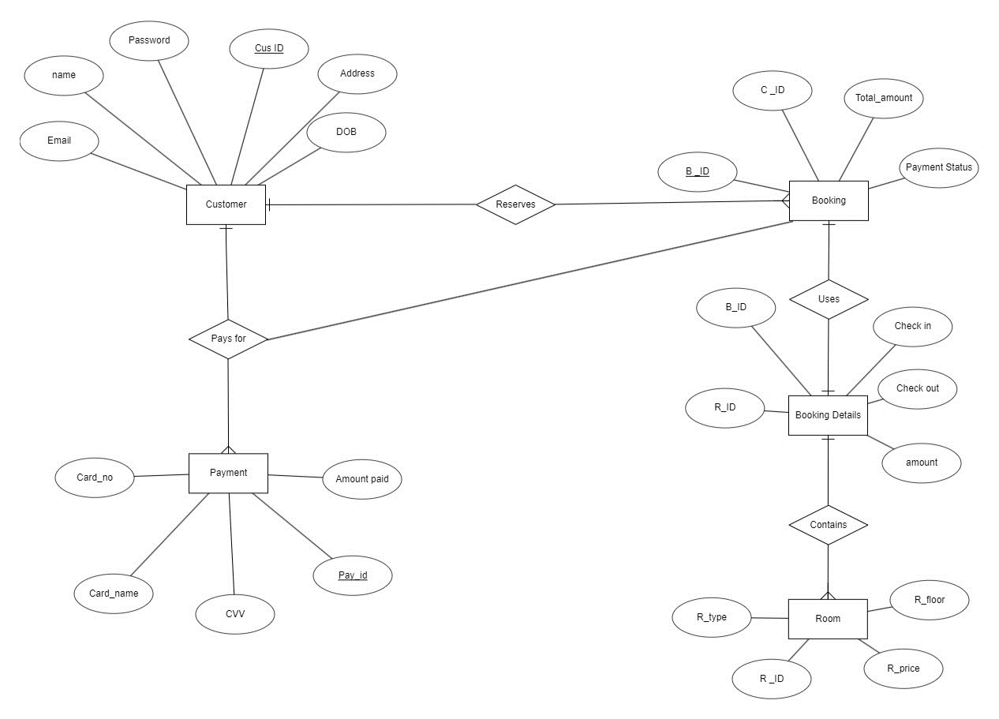

**CLASS DIAGRAM:**

